

Payment

Requirement Document

**Version 1.3**

|  |  |
| --- | --- |
| ***Corporate Office & Development Center*** | ***Offshore Development Center*** |
| *5 Concourse Parkway*  *Suite 3200, Atlanta, Georgia 30328*  *Tel 678.281.2014*  *Fax: 678.281.2019* | *Plot # 122 & 123, N.S.E.Z, Phase -2*  *NOIDA, UP 201 305*  *India*  *Tel: 91.11.91.2510483* |

|  |  |  |  |  |
| --- | --- | --- | --- | --- |
| **Author** | | | | |
| **Name** | **Role** | **Date of Preparation** | **Signature** | |
| Evelyn Yap | Project manager | 19-Jan-2015 | Evelyn | |
| **Reviewer(s)** | | | | |
| **Name** | **Role** | **Date of Review** | **Signature** | |
| Pravesh Kumar | Manager Projects |  |  | |
|  |  |  |  | |
| **Approver** | | | | |
| **Name** | **Role** | **Date of Approval** | **Signature** | |
| ChengChoon Yip | VP Ebix Exchange  Asia |  |  | |
| **Document Path** | **Version Number** | **Date of Release** | | |
|  | 1.00 | 19-Jan-2015 | | |
| **Revision History** | | | | |
| **Version Number** | **Date of Release** | **Section/ Page # Changed** | | **Details of Changes** |
| 1.00 | 19-Jan-2015 | All | | Document created |
| 1.1 | 20-Jan-15 | Page 30 | | Added clarification required by India Ebix team |
| 1.2 | 20-Jan-15 | Page 30 | | Updated clarification required points with coloring and edited clarifications |
| 1.3 | 23-Jan-15 |  | | Updated comments from SG |

|  |  |  |
| --- | --- | --- |
| **References** | | |
| **Document** | **Date Received** | **Author** |
|  |  |  |

Contents

2. Overview 4

**a.** Module 4

**b.** Development Type 4

3. Payment Processing 4

3.1 3.1 Under Claims Adjustment: 5

3.2 Under Claims Payment Processing: 5

4. Screenshots 7

4.1 Payment Tab 7

4.2 TPPD Payment Request 8

4.3 TPPD Payment Approval 9

4.4 TPBI Payment Request 10

4.5 OD Payment Request 11

4.6 OD Payment Approval 12

5. Payment Request With Field List 13

6. Payment Form With Field List 16

7. NEL Payment Form With Field List 19

8. Payment Summary With Field List 22

9. Debit Note Requisition Form 24

10. Cheque Cancellation Or Reissue Memo With Field List 26

11. Rule 27

12. Implementation 27

12.1 Current Implementation 27

12.2 Targeted Implementation 28

13. Change Required 28

# Overview

|  |  |  |  |
| --- | --- | --- | --- |
| ☒ | New | ☐ | Change Request |

* 1. Module

|  |  |  |  |  |  |
| --- | --- | --- | --- | --- | --- |
| ☐ | Diary | ☐ | System Admin Module | ☐ | Claim Registration |
| ☒ | Claim Payment | ☐ | Claim Recovery | ☐ | Claim Enquiry |
| ☐ | Upload | ☐ | Reports |  |  |

* 1. Development Type

|  |  |  |  |  |  |
| --- | --- | --- | --- | --- | --- |
| ☒ | Functionality | ☒ | Integration | ☐ | Rule |
| ☐ | Report | ☒ | Field | ☒ | Screen |

# Payment Processing

## Under Claims Adjustment:

* Summary of Payment Details will be read-only. User has to go to Claims Payment Processing Menu to create Payment Approval Request

## Under Claims Payment Processing:

* Change search fields: Policy No. to Claim No. / Insured Name to Claimant Name / Remove Organization Country or rename to Claim Type and selection = Own Damage / Property Damage / Bodily Injury. Include Search Field for Claim Type: <<Dropdown – Own Damage / Property Damage / Bodily Injury >>
* Search Results:

|  |  |  |  |  |  |  |
| --- | --- | --- | --- | --- | --- | --- |
| S/No. | Claim No. | Claimant Name | Claim Type | Accident Date | Vehicle No. | Action |
| 1 |  |  |  |  |  | << Select >> |
|  |  |  |  |  |  |  |

Note: Upon clicking on Select, System will bring user to Payment Processing Screen (similar to screen layout for Claim Registration, all tabs are blocked out except for Payment Tab)

* Payment Tab Grid:

|  |  |  |  |  |  |  |  |  |
| --- | --- | --- | --- | --- | --- | --- | --- | --- |
| +/- | Claim Type | Claimant Record Number | Claimant Name | Amount Paid | Payee | Approved Date | Status | Action |
| + | OD |  |  |  |  |  |  |  |
| 🡪 | OD-001 |  |  |  |  |  | << Approved / Rejected >> | << Select >> |
| + | PD |  |  |  |  |  |  |  |
| 🡪 | PD-001 |  |  |  |  |  | << Approved / Rejected >> | << Select >> |
| 🡪 | PD-002 |  |  |  |  |  | << Approved / Rejected >> | << Select >> |
| + | BI |  |  |  |  |  |  |  |
| 🡪 | BI-001 |  |  |  |  |  | << Approved / Rejected >> | << Select >> |
| 🡪 | BI-002 |  |  |  |  |  | << Approved / Rejected >> | << Select >> |

* When User clicks on Select, the Relevant Payment Approval Request Screen will appear:

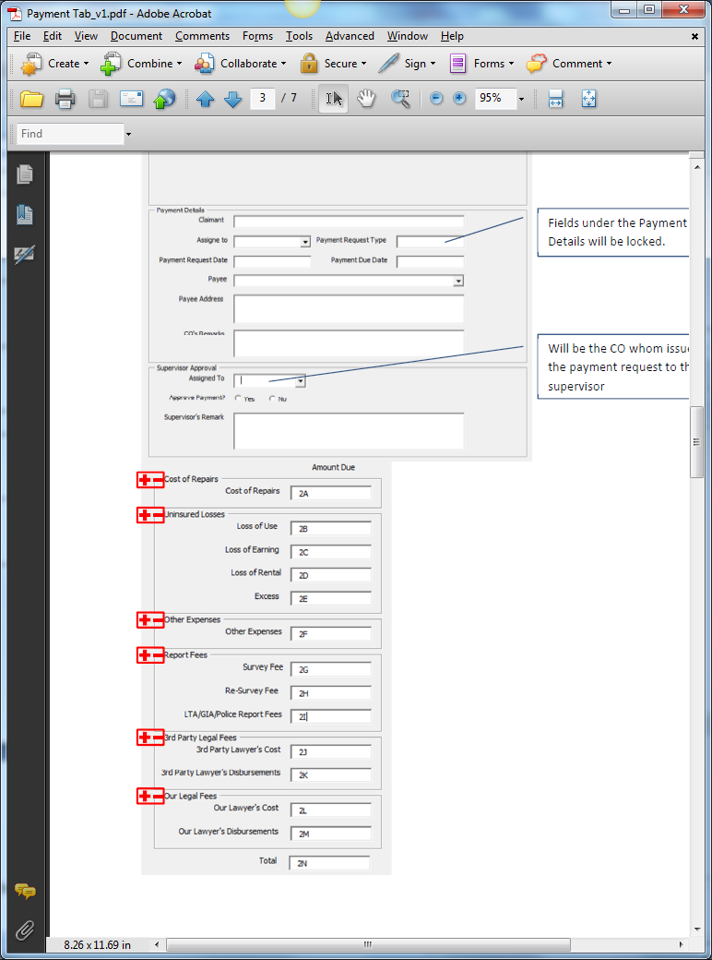

Relevant Fields from Mandate Request Screen.

Include Approved Mandate Column. Read Only. Amount Due is less than or equal to this value. Editable by CO and Supervisor

Address as Address1, Address2, Address3, Postal Code

Populate Created Service Providers

Validate with Supervisor’s FAL

* Supervisor Approval Section to have Access Rights.
* Validation: Mandate must be approved and there must be Reserve created before User can create any Payment Approval Request
* Validation: If Initial Reserve = 0, no Payment is allowed. If Mandate Status is Approved, show Outstanding Amount and Initial Reserve has values, Payment is allowed. If Mandate Status is Pending, show Pending Status. If Mandate Status is rejected, show status as 0. If Mandate is not created, show status as 0.
* Under Payment Due Date: System is to keep track of this date and when it is expired, system will highlight this entry as red in the Diary Listing. To highlight entry as green 2 days before Expiry Date.

# Screenshots

## Payment Tab – Please ignore this screenshot. Grid is to follow the one on Page 5: Payment Tab Grid

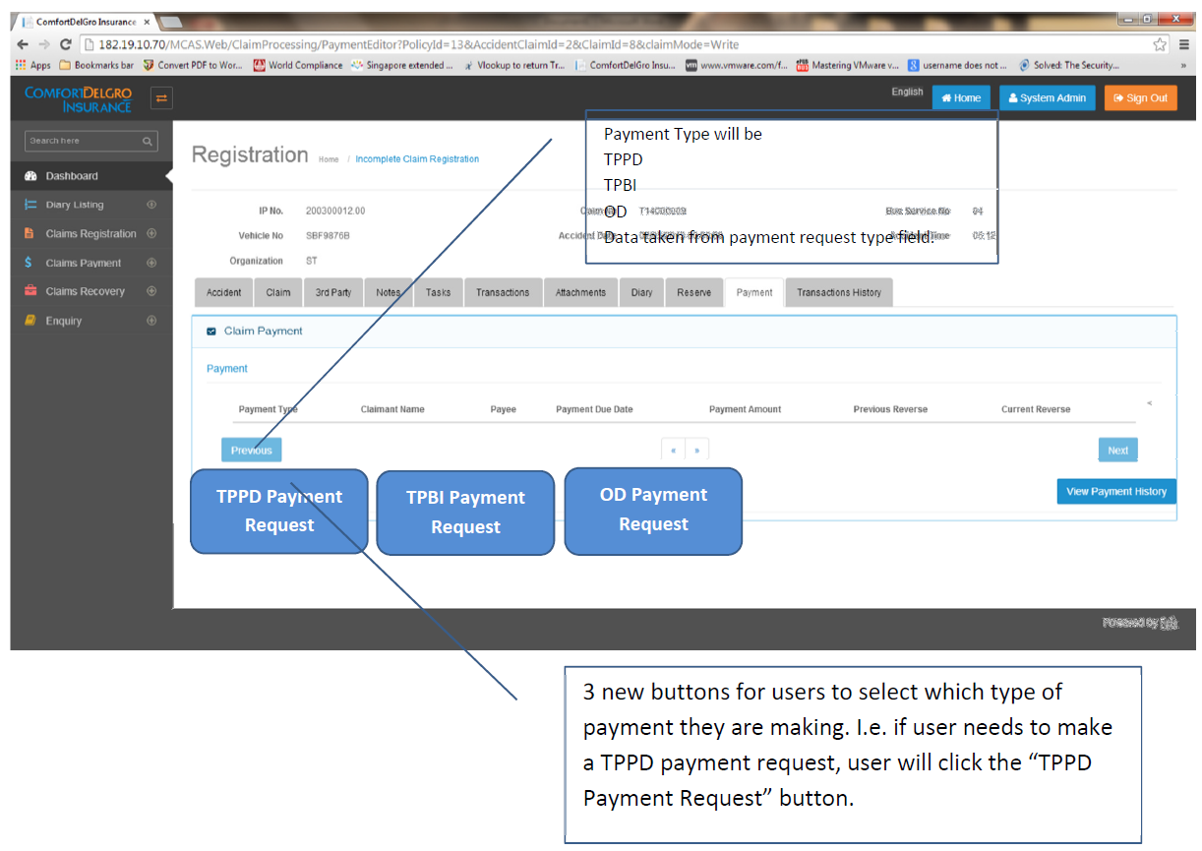

## TPPD Payment Request – Please ignore this layout for development. Only use the Information that is pointed out.

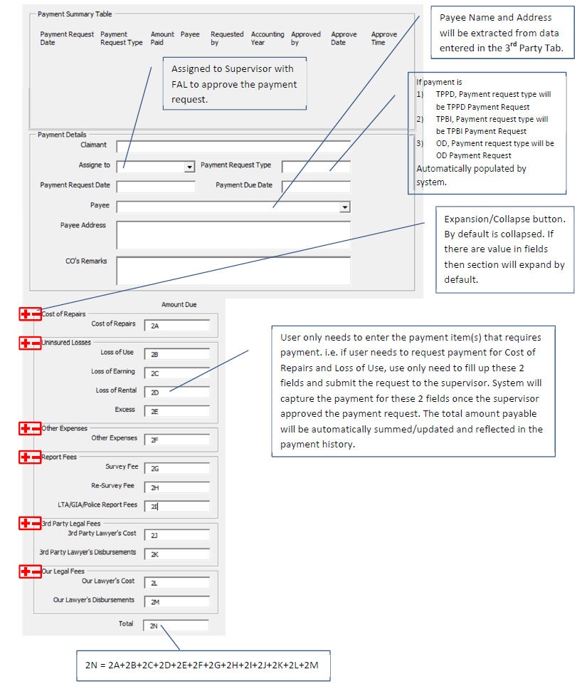

## TPPD Payment Approval – Only use this for TPPD Payment when TPPD Claim is selected (for both CO and Supervisor Users). Supervisor Approval Section is blocked out for CO Users.

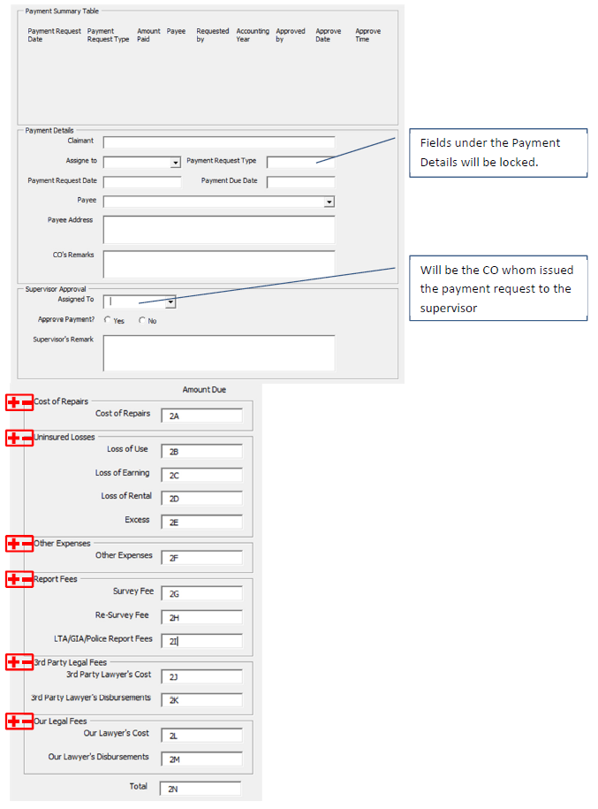

## TPBI Payment Request -- Please ignore this layout for development. Only use the Information that is pointed out. Please follow TPPD Payment Approval Layout for TPBI Payment Approval as well.

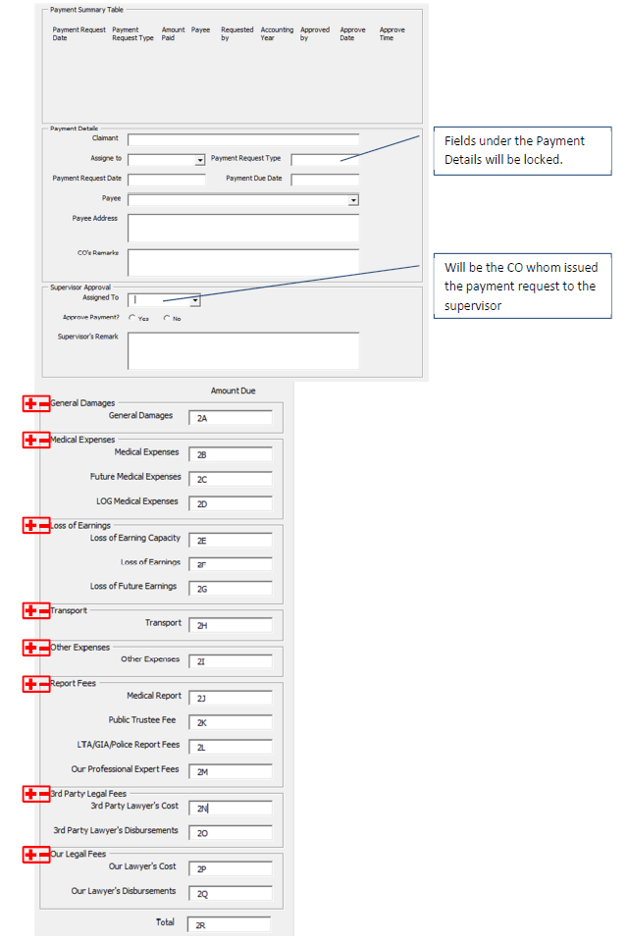

## OD Payment Request – Please ignore this layout for development. Only take note of the points. Use OD Payment Approval for Layout.

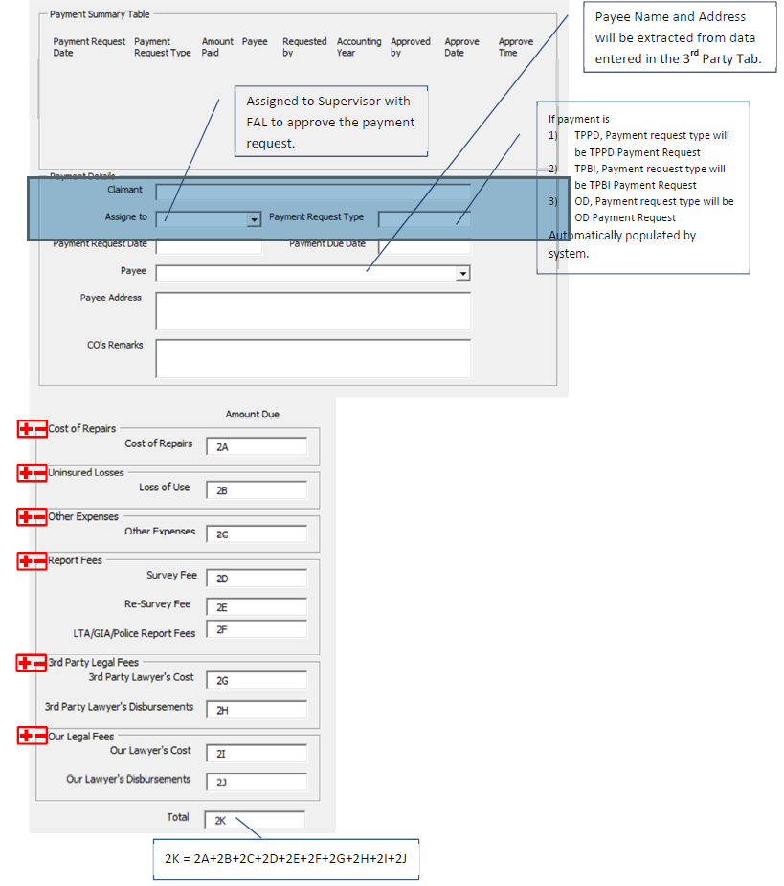

## OD Payment Approval

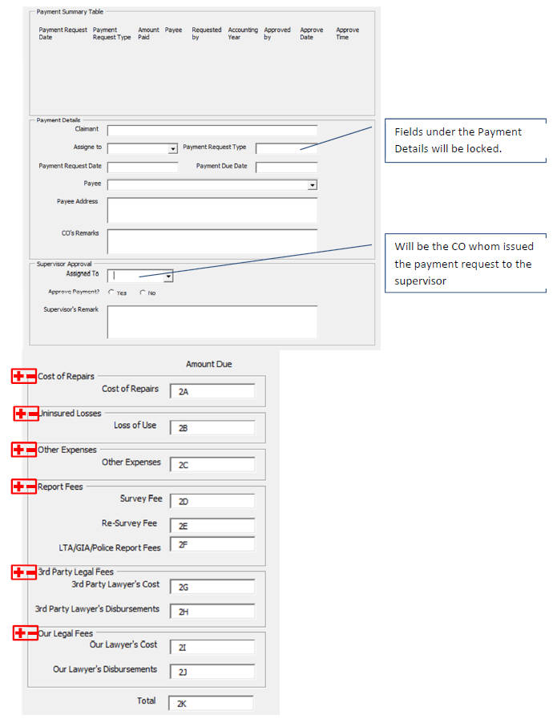

# Payment Request With Field List

|  |  |  |  |  |  |  |
| --- | --- | --- | --- | --- | --- | --- |
| **Form name** | Payment Request | | |  |  |  |
| Description |  | | |  | | |
| s.no. | Field number as per screen | Field names | screen Name | screen field name | EBIX Remarks | CDGI Remarks |
| 1 | F-1 | Field not confirm | User Admin | User | Pre-fixed or User ID? |  |
| 2 | F-2 | Label " payment request " | Unknown | Unknown | To Be Pre-fixed? |  |
| 3 | F-3 | please refer attached screen shot | Insurance Master | Insurer |  |  |
| 4 | F-4 | please refer attached screen shot | Payment | Local Currency |  |  |
| 5 | F-5 | please refer attached screen shot | Unknown | Unknown | Insurer's Address? |  |
| 6 | F-6 | please refer attached screen shot | Unknown | Unknown | Insurer's Address? |  |
| 7 | F-7 | please refer attached screen shot | Unknown | Unknown |  |  |
| 8 | F-8 | please refer attached screen shot | Unknown | Unknown |  |  |
| 9 | F-9 | please refer attached screen shot | Unknown | Unknown |  |  |
| 10 | F-10 | please refer attached screen shot | Unknown | Unknown | Is This from Finance Tab? |  |
| 11 | F-11 | please refer attached screen shot | Unknown | Unknown | Is This from Finance Tab? |  |
| 12 | F-12 | please refer attached screen shot | Unknown | Unknown | Is This from Finance Tab? |  |
| 13 | F-13 | please refer attached screen shot | Unknown | Unknown | Is This from Finance Tab? |  |
| 14 | F-14 | please refer attached screen shot | Unknown | Unknown | Is This from Finance Tab? |  |
| 15 | F-15 | please refer attached screen shot | Unknown | Unknown | Is This from Finance Tab? |  |
| 16 | F-16 | please refer attached screen shot | Unknown | Unknown | Is This from Finance Tab? |  |
| 17 | F-17 | please refer attached screen shot | Unknown | Unknown | Is This from Finance Tab? |  |
| 18 | F-18 | please refer attached screen shot | Unknown | Unknown | Is This from Finance Tab? |  |
| 19 | F-19 | please refer attached screen shot | Unknown | Unknown | Is This from Finance Tab? |  |
| 20 | F-20 | please refer attached screen shot | Unknown | Unknown | Is This from Finance Tab? |  |
| 21 | F-21 | please refer attached screen shot | User Admin | User | Pre-fixed? |  |
| 22 | F-22 | please refer attached screen shot | User Admin | Group / Department | Pre-fixed? |  |
| 23 | F-23 | please refer attached screen shot |  |  | Pre-fixed? |  |
| 24 | F-24 | please refer attached screen shot | User Admin | User | Pre-fixed? |  |
| 25 | F-25 | please refer attached screen shot | User Admin | Group / Department | Pre-fixed? |  |
| 26 | F-26 | please refer attached screen shot | Unknown | Unknown |  |  |
| 27 | F-27 | please refer attached screen shot | Payment | Local Currency | Or From Finance Tab? |  |
| 28 | F-28 | please refer attached screen shot | Unknown | Unknown |  |  |
| 29 | F-29 | please refer attached screen shot | Unknown | Unknown |  |  |
| 30 | F-30 | please refer attached screen shot | User Admin | User | Pre-fixed or based on User ID? |  |
| 31 | F-31 | please refer attached screen shot | Claim | Preview Documents | Date that Document is generated? |  |

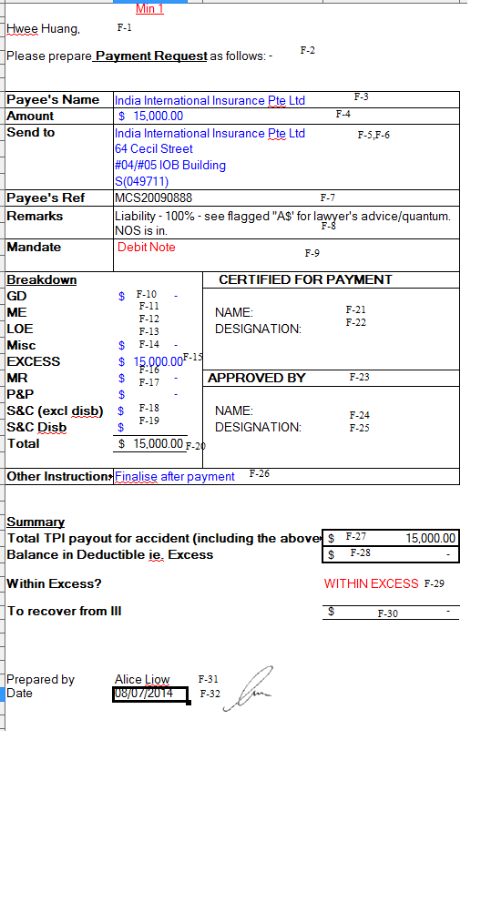

# Payment Form With Field List

|  |  |  |  |  |  |  |
| --- | --- | --- | --- | --- | --- | --- |
| **Form name** | Payment Form | | |  |  |  |
| Description |  | | |  | | |
| s.no. | Field number as per screen | Field names | screen Name | screen field name | EBIX Remarks | CDGI Remarks |
| 1 | F-1 | please refer attached screen shot | Accident | IP No |  |  |
| 2 | F-2 | please refer attached screen shot | User Admin | User | Blank or Pre-fixed or based on User ID? |  |
| 3 | F-3 | please refer attached screen shot | Claims | Preview Documents | Date that Document is generated? |  |
| 4 | F-4 | please refer attached screen shot | User Admin | Group / Department | Blank or Pre-fixed or based on User ID? |  |
| 5 | F-5 | please refer attached screen shot | User Admin | User | Blank or Pre-fixed or based on User ID? |  |
| 6 | F-6 | please refer attached screen shot | User Admin | Group / Department | Blank or Pre-fixed or based on User ID? |  |
| 7 | F-7 | 1st party involved in accident | Accident | Vehicle No | Claimant Name / Payee Name / Bus Service No. / Vehicle No? |  |
|  | F-29 | 2nd party involved in accident | Unknown | Unknown | Do we need another Claimant Name / Payee Name / Bus Service No. / Vehicle No? |  |
| 8 | F-8 | road name | Accident | Road Name |  |  |
| 9 | F-9 | accident date | Accident | Accident Date |  |  |
| 10 | F-10 | please refer attached screen shot | Payment | Local Currency |  |  |
| 11 | F-11 | please refer attached screen shot |  |  | Is this from the Finance Tab? |  |
| 12 | F-12 | please refer attached screen shot | Payment | Payee | Unknown / Claimant Name / Payee Name? |  |
| 13 | F-13 | please refer attached screen shot | Unknown | Unknown | Is this from the Finance Tab? |  |
| 14 | F-14 | please refer attached screen shot | Unknown | Unknown | Is this from the Finance Tab? |  |
| 15 | F-15 | please refer attached screen shot | Unknown | Unknown | Is this from the Finance Tab? |  |
| 16 | F-16 | please refer attached screen shot | Unknown | Unknown | Is this from the Finance Tab? |  |
| 17 | F-17 | please refer attached screen shot | Unknown | Unknown | Is this from the Finance Tab? |  |
| 18 | F-18 | please refer attached screen shot | Unknown | Unknown | Is this from the Finance Tab? |  |
| 19 | F-19 | please refer attached screen shot | Unknown | Unknown | Is this from the Finance Tab? |  |
| 20 | F-20 | please refer attached screen shot | Unknown | Unknown | Is this from the Finance Tab? |  |
| 21 | F-21 | please refer attached screen shot | Unknown | Unknown | Is this from the Finance Tab? |  |
| 22 | F-22 | please refer attached screen shot | Unknown | Unknown | Is this from the Finance Tab? |  |
| 23 | F-23 | please refer attached screen shot | Unknown | Unknown | Is this from the Finance Tab? |  |
| 24 | F-24 | please refer attached screen shot | Unknown | Unknown | Is this from the Finance Tab? |  |
| 25 | F-25 | please refer attached screen shot | Unknown | Unknown | Is this from the Finance Tab? |  |
| 26 | F-26 | please refer attached screen shot | Unknown | Unknown | Is this from the Finance Tab? |  |
| 27 | F-27 | please refer attached screen shot | Unknown | Unknown | Is this from the Finance Tab? |  |
| 28 | F-28 | please refer attached screen shot | Unknown | Unknown | Is this from the Finance Tab? |  |

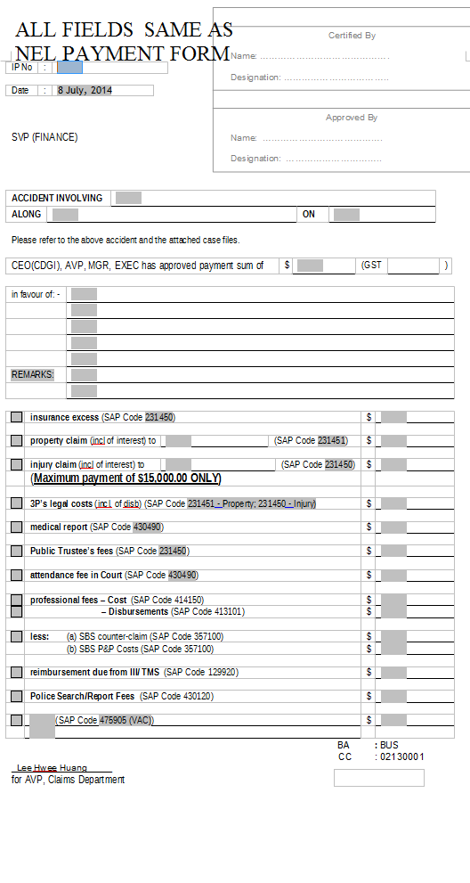

# NEL Payment Form With Field List

|  |  |  |  |  |  |  |
| --- | --- | --- | --- | --- | --- | --- |
| **Form name** | NEL Payment form | | |  |  |  |
| Description |  | | |  | | |
| s.no. | Field number as per screen | Field names | screen Name | screen field name | EBIX Remarks | CDGI Remarks |
| 1 | F-1 | please refer attached screen shot | Accident | IP No |  |  |
| 2 | F-2 | please refer attached screen shot | User Admin | User | Blank or Pre-fixed or based on User ID? |  |
| 3 | F-3 | please refer attached screen shot | Claims | Preview Documents | Date that Document is generated? |  |
| 4 | F-4 | please refer attached screen shot | User Admin | Group / Department | Blank or Pre-fixed or based on User ID? |  |
| 5 | F-5 | please refer attached screen shot | User Admin | User | Blank or Pre-fixed or based on User ID? |  |
| 6 | F-6 | please refer attached screen shot | User Admin | Group / Department | Blank or Pre-fixed or based on User ID? |  |
| 7 | F-7 | 1st party involved in accident | Accident | Vehicle No | Claimant Name / Payee Name / Bus Service No. / Vehicle No? |  |
|  | F-29 | 2nd party involved in accident | Unknown | Unknown | Do we need another Claimant Name / Payee Name / Bus Service No. / Vehicle No? |  |
| 8 | F-8 | road name | Accident | Road Name |  |  |
| 9 | F-9 | accident date | Accident | Accident Date |  |  |
| 10 | F-10 | please refer attached screen shot | Payment | Local Currency |  |  |
| 11 | F-11 | please refer attached screen shot |  |  | Is this from the Finance Tab? |  |
| 12 | F-12 | please refer attached screen shot | Payment | Payee | Unknown / Claimant Name / Payee Name? |  |
| 13 | F-13 | please refer attached screen shot | Unknown | Unknown | Is this from the Finance Tab? |  |
| 14 | F-14 | please refer attached screen shot | Unknown | Unknown | Is this from the Finance Tab? |  |
| 15 | F-15 | please refer attached screen shot | Unknown | Unknown | Is this from the Finance Tab? |  |
| 16 | F-16 | please refer attached screen shot | Unknown | Unknown | Is this from the Finance Tab? |  |
| 17 | F-17 | please refer attached screen shot | Unknown | Unknown | Is this from the Finance Tab? |  |
| 18 | F-18 | please refer attached screen shot | Unknown | Unknown | Is this from the Finance Tab? |  |
| 19 | F-19 | please refer attached screen shot | Unknown | Unknown | Is this from the Finance Tab? |  |
| 20 | F-20 | please refer attached screen shot | Unknown | Unknown | Is this from the Finance Tab? |  |
| 21 | F-21 | please refer attached screen shot | Unknown | Unknown | Is this from the Finance Tab? |  |
| 22 | F-22 | please refer attached screen shot | Unknown | Unknown | Is this from the Finance Tab? |  |
| 23 | F-23 | please refer attached screen shot | Unknown | Unknown | Is this from the Finance Tab? |  |
| 24 | F-24 | please refer attached screen shot | Unknown | Unknown | Is this from the Finance Tab? |  |
| 25 | F-25 | please refer attached screen shot | Unknown | Unknown | Is this from the Finance Tab? |  |
| 26 | F-26 | please refer attached screen shot | Unknown | Unknown | Is this from the Finance Tab? |  |
| 27 | F-27 | please refer attached screen shot | Unknown | Unknown | Is this from the Finance Tab? |  |
| 28 | F-28 | please refer attached screen shot | Unknown | Unknown | Is this from the Finance Tab? |  |

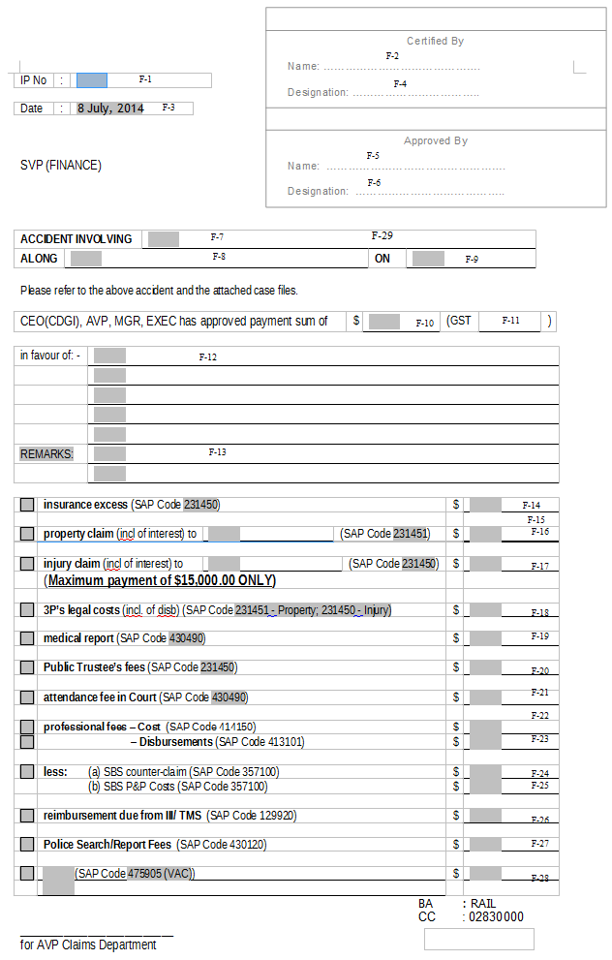

# Payment Summary With Field List

|  |  |  |  |  |  |  |
| --- | --- | --- | --- | --- | --- | --- |
| **Form name** | Payment summary | | |  |  |  |
| Description |  | | |  | | |
| s.no. | Field number as per screen | Field names | screen Name | screen field name | EBIX Remarks | CDGI Remarks |
| 1 | F-1 | claim type | 3rd Party | Other Party Type |  |  |
| 2 | F-2 | IP no. | Accident | IP No. |  |  |
| 3 | F-3 | File no. | Unknown | Unknown | Is This From Finance Tab? |  |
| 4 | F-4 | C/F | Unknown | Unknown | Is This From Finance Tab? |  |
| 5 | F-5 | please refer attached screen shot | Payment | Claimant Name |  |  |
| 6 | F-6 | please refer attached screen shot | Payment | Payee's Name |  |  |
| 7 | F-7 | please refer attached screen shot | Reserve | Previous Reserve |  |  |
| 8 | F-8 | please refer attached screen shot | Unknown | Unknown |  |  |
| 9 | F-9 | please refer attached screen shot | Reseve | Current Reserve |  |  |
| 10 | F-10 | please refer attached screen shot | Reserve | Date |  |  |
| 11 | F-11 | please refer attached screen shot | Unknown | Unknown |  |  |
| 12 | F-12 | please refer attached screen shot | Unknown | Unknown |  |  |
| 13 | F-13 | please refer attached screen shot | Reserve | Current Reserve |  |  |
| 14 | F-14 | please refer attached screen shot | Unknown | Unknown |  |  |
| 15 | F-15 | please refer attached screen shot | Unknown | Unknown |  |  |
| 16 | F-16 | please refer attached screen shot | Payment | Claimant Name |  |  |
| 17 | F-17 | please refer attached screen shot | Payment | Payee's Name |  |  |
| 18 | F-18 | please refer attached screen shot | Reserve | Previous Reserve |  |  |
| 19 | F-19 | please refer attached screen shot | Unknown | Unknown |  |  |
| 20 | F-20 | please refer attached screen shot | Reseve | Current Reserve |  |  |
| 21 | F-21 | please refer attached screen shot | Reserve | Date |  |  |
| 22 | F-22 | please refer attached screen shot | Unknown | Unknown |  |  |
| 23 | F-23 | please refer attached screen shot | Unknown | Unknown |  |  |
| 24 | F-24 | please refer attached screen shot | Reserve | Current Reserve |  |  |

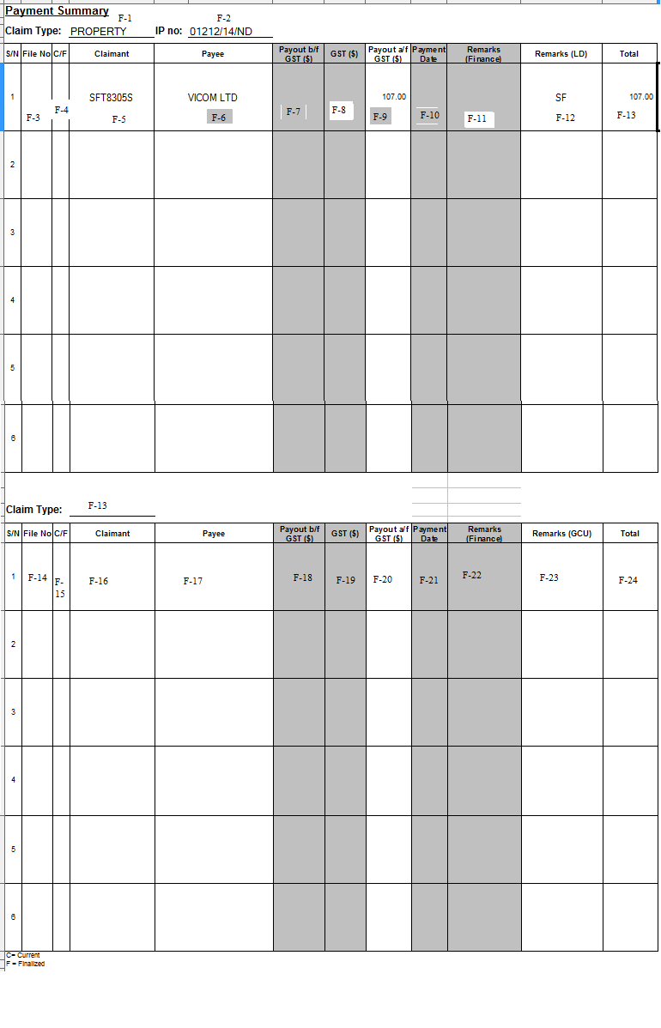

# Debit Note Requisition Form

|  |  |  |  |  |  |  |
| --- | --- | --- | --- | --- | --- | --- |
| **Form name** | Debit Note Requisition Form | | |  |  |  |
| Description |  | | |  | | |
| s.no. | Field number as per screen | Field names | screen Name | screen field name | EBIX Remarks | CDGI Remarks |
| 1 | F-1 | Date | Claims | Preview Documents | Date that Document is generated? |  |
| 2 | F-2 | IP no. | Accident | IP No. |  |  |
| 3 | F-3 | field not confirm | Accident | Vehicle No. |  |  |
| 4 | F-4 | field not confirm | Accident | Accident Date |  |  |
| 5 | F-5 | injured person name | Payment | Payee |  |  |
| 6 | F-6 | please refer attached screen shot | Unknown | Unknown | Payee's NRIC? |  |
| 7 | F-7 | company name | Insurance Policy | Insurer |  |  |
| 8 | F-8 | ref number | Unknown | Unknown |  |  |
| 9 | F-9 | Address 1 | Unknown | Unknown | Insurer's Address? |  |
| 10 | F-10 | Address 2 | Unknown | Unknown | Insurer's Address? |  |
| 11 | F-11 | s.no. | Unknown | Unknown | Is this from the Finance or Payment Tab? |  |
| 12 | F-12 | description | Unknown | Unknown | Is this from the Finance or Payment Tab? |  |
| 13 | F-13 | Amount % ( without GST) | Unknown | Unknown | Is this from the Finance or Payment Tab? |  |
| 14 | F-14 | GST % | Unknown | Unknown | Is this from the Finance or Payment Tab? |  |
| 15 | F-15 | SAP CODE | Unknown | Unknown | Is this from the Finance or Payment Tab? |  |
| 16 | F-16 | Cost center | Unknown | Unknown | Is this from the Finance or Payment Tab? |  |
| 17 | F-17 | total( Amount ($) ( without GST) | Unknown | Unknown | Is this from the Finance or Payment Tab? |  |
| 18 | F-18 | GST ( $) | Unknown | Unknown | Is this from the Finance or Payment Tab? |  |

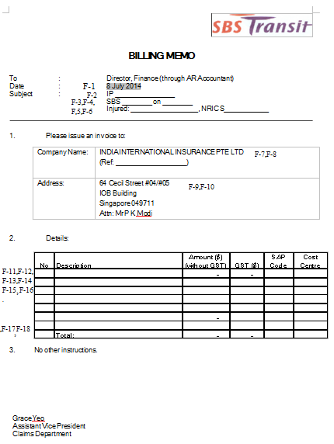

# Cheque Cancellation Or Reissue Memo With Field List

|  |  |  |  |  |  |  |
| --- | --- | --- | --- | --- | --- | --- |
| **Form name** | Cheque Cancellation Or Reissue Memo | | |  |  |  |
| Description |  | | |  | | |
| s.no. | Field number as per screen | Field names | screen Name | screen field name | EBIX Remarks | CDGI Remarks |
| 1 | F-1 | Please refer screen shot | Accident | IP No. / Claim No. |  |  |
| 2 | F-2 | field not confirm | Unknown | Unknown |  |  |
| 3 | F-3 | date | Claims | Preview Documents | Date that Document is generated? |  |
| 4 | F-4 | 1st party involved in accident | Accident | Vehicle No. |  |  |
| 5 | F-5 | 2nd party involved in accident | Unknown | Unknown | Another Vehicle No.? |  |
| 6 | F-6 | road name | Accident | Road Name |  |  |
| 7 | F-7 | accident date | Accident | Accident Date |  |  |
| 8 | F-8 | Please refer screen shot | Unknown | Unknown |  |  |
| 9 | F-9 | Please refer screen shot | Unknown | Unknown |  |  |
| 10 | F-10 | Please refer screen shot | Payment | Local Currency |  |  |
| 11 | F-11 | Please refer screen shot | Payment | Payee |  |  |
| 12 | F-12 | Please refer screen shot | Payment | Local Currency |  |  |
| 13 | F-13 | Please refer screen shot | Payment | Payee |  |  |

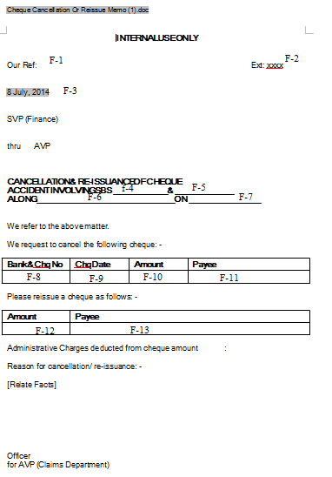

# Rule

|  |  |  |  |  |
| --- | --- | --- | --- | --- |
| **IF** | **Then** | **Else** | **And** | **Or** |
|  |  |  |  |  |
|  |  |  |  |  |

# Implementation

## Current Implementation

* Payment does not exist in application

## Targeted Implementation

* Payment Creation

# Change Required

# Clarification Required

|  |  |  |
| --- | --- | --- |
| S.No. | Page no | Doubts |
| 1 | 5 | Duplicate claimant name column mentioned needs to be removed and can we add claimant record number in grid screen as per theme of claim registration module grid screens? |
| 2 | 7 | We did not understand mentioned line on this page as "editable by CO and SP" , line on page 7 |
| 3 | 7 | On Grid screen only two status has been mentioned " approved and pending" but on Validation , there are multiple other status has been defined. Do we need to show "0" also in status ? Please mention in table , for better understanding.  We need to discuss status of payment requirement in meeting. |
| 4 | 8 | Please provide screen layout of dairy listing screen.  We need to discuss diary module of payment requirement in meeting. |
| 5 | 8 | As per theme of claim registration , user is selection records from Grid itself , to assign reserve and mandate, so can we follow same theme and remove button as mentioned on page 8. |
| 6 | 9 | On Grid screen, do we need to add Accounting year column?  Please provide details of this field. |
| 7 | 9 | Will the accounting year start from 1 march 2014 to 30 april 2015 and will be shown as 2014 - 2015? |
| 8 | 11 | Please provide display criteria of Payment approval screen will come? Will it come by default when user select any record from grid? |
| 9 | 12 | From which field and screen, Payee name and address will be extracted ? Do we need to take values from service provider screen? Please mention field names of screen. |
| 10 | 13 | Do we need to make payment request type as read only ? |
| 11 | 14 to 30 | Need to discuss in detail in meeting for document generation criteria of these forms and for finalized field values sources of these forms. |

Responses:

|  |  |  |
| --- | --- | --- |
| S.No. | Page no | Responses |
| 1 | 5 | Duplicated Claimant Name Column has been deleted. Okay to add the Claimant Record Number to standardized the theme layout. |
| 2 | 7 | Scenario:  1) CO will come in the make Payment Request and input values in the Amount Due Column for various Payment Items (e.g. Cost of Repair) and submit the Request. System will make sure that the input values do not exceed the Approved Mandate value. User cannot enter any values for any fields if there are no Approved Mandate for that particular item.  2) User submits the Request to Supervisor for Approval.  3) Supervisor receives and looks through and directly edit the value input by CO. Reasons for editing will be in the Supervisors’ Remarks Section. System will check that Supervisor’s editing does not exceed the Approved Mandate as well.  4) Supervisor will approve or reject after editing. If Supervisor clicks on Approve, Reserve and Mandate Value will be updated accordingly.  5) When Supervisor approves / rejects the claim wrongly, there is a link beside the claim that allows Supervisor to undo the approve/reject. An email will be sent to CO to inform that “Payment Status for Claim # has been changed by Supervisor, please kindly check” if this link has been clicked and activated.  6) System needs to undo the value changes made to the Reserve and Mandate when Supervisor clicks on the undo link. |
| 3 | 7 | Statuses To be Shown:  1) When Reserve = 0, Payment Request is not allowed, Status is blank  2) If Mandate is approved, show Current Reserve Value, Payment Request is allowed, Status is blank  3) If Mandate Status is pending, Payment Request is not allowed, Payment Status is blank.  4) If Mandate Status is rejected, Payment Request is not allowed, Payment Status is blank.  5) If Mandate is not created, this Claim Entry will not be shown on Payment Grid. |
| 4 | 8 | Use the Payment Tab Grid for Diary Listing. Please ignore the Screenshots for 4.1 Payment Tab; 4.2 TPPD Payment Request, 4.4 TPBI Payment Request. 4.5 Payment Request. Only take the points for references. The Payment Approval Screens are the one to be developed. We just need to block out the Supervisor Section for CO Group Users. |
| 5 | 8 | Use the Payment Tab Grid as layout for selecting claims for viewing and editing. We do not need the Buttons. |
| 6 | 9 | Accounting Year Field is the year that the Payment Request is approved. Just need to show in this format: YYYY, ie 2015 |
| 7 | 9 | Show YYYY. |
| 8 | 11 | Yes. The Payment Approval Screens for all Claim Types are the default. Only need to block out the Supervisor Section for CO Users and editable for Supervisor Users (with FAL). |
| 9 | 12 | System will populate the Claimant Name and personal information that is created for the particular claim as well as the list of Service Providers that are attached to the claim. Under Payee field, there will be a dropdown for user to select, and upon selecting, System will automatically populate the rest of payee’s information. |
| 10 | 13 | Yes. Read only. This is because user will be clicking on the Claims directly. |
| 11 | 14 – 30 | As mentioned in previous discussion, this can only be discussed when the UAT Screens are out and finalized so that CDGI can start mapping the fields available on screen to one on Document. |